1. **Agenda:**
   1. How to create a stub that matches a particular URL.
2. In a previous lecture, we learnt about how to create a stub that matches any URL.  
   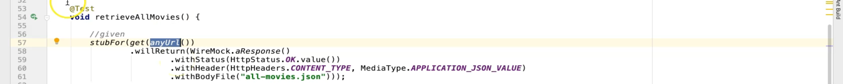
3.   
     
   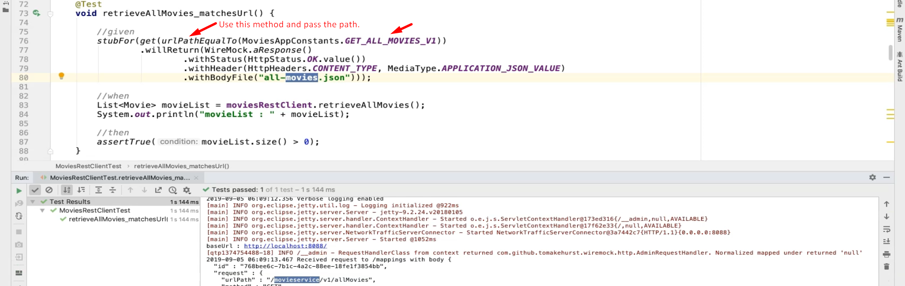
4. Let’s analyze the WireMock Log from the console to understand what is happening.
5. 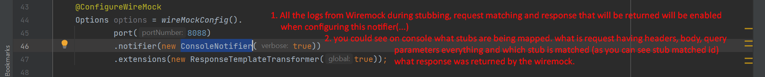The log study was taken from ChatGPT [Link](https://chatgpt.com/c/6777e97f-bc88-8004-93bf-0a6a331241de#:~:text=Let%E2%80%99s%20analyze%20the%20WireMock%20log%20step%2Dby%2Dstep%20to%20understand%20what%E2%80%99s%20happening%20in%20this%20process):
6. 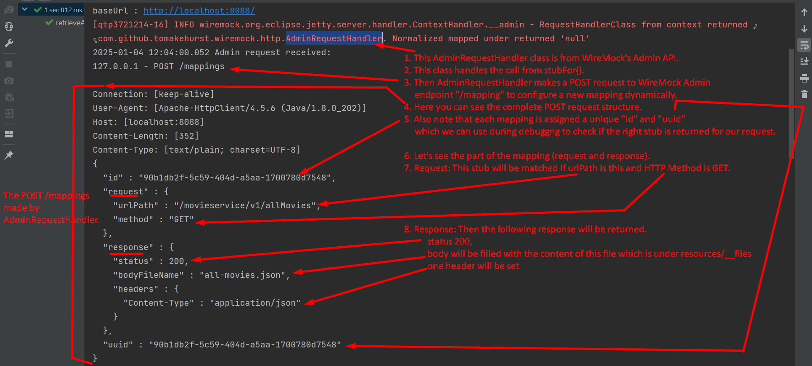
7. Let’s talk log about Client Request Matching the Stub:
8. 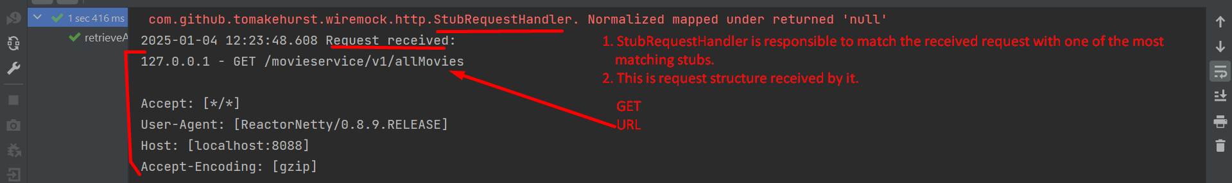
9. 